While most of us boaters have wonderful imaginings that boat cooking will be grilling fresh seafood off the transom while the sun goes down as we sip a chilled glass of chardonnay, we all know that the reality is that we can often be down to just the tinned and dried provisions that we have stored in a Rubbermaid bin in the hold when dinnertime approaches. To that end I have gathered some great recipes that have become some of our very favourites that need very few fresh ingredients. The main ingredient in our favourite is SPAM. Now before you scroll past hang on! This preparation takes a whole new approach to SPAM, treating like a pre-seasoned ground meat that you crumble and cook to a lovely crispy texture. Add some dried chile flakes and caramelized green onions and you end up with a delicate sweet and spicy fantastic pasta dish. So stock up the larder with some SPAM and pasta and you will never go hungry!
A Spicey Caramelized Spam & Scallion Pasta
- Thanks to Kelly Lerigny for this Special.

SPICY CARAMELIZED SPAM + SCALLION PASTA
Ingredients – for 2 large servings
- 2 T butter
- small bunch green onions (about 5-6), finely chopped, plus extra for serving
- salt and pepper
- 6 oz (half can) spam
- ½ T sugar
- ½ T sesame oil
- generous pinch crushed chile flake
- hot cooked pasta of your choice (about 150g precooked weight)
- ¼ cup reserved pasta cooking water

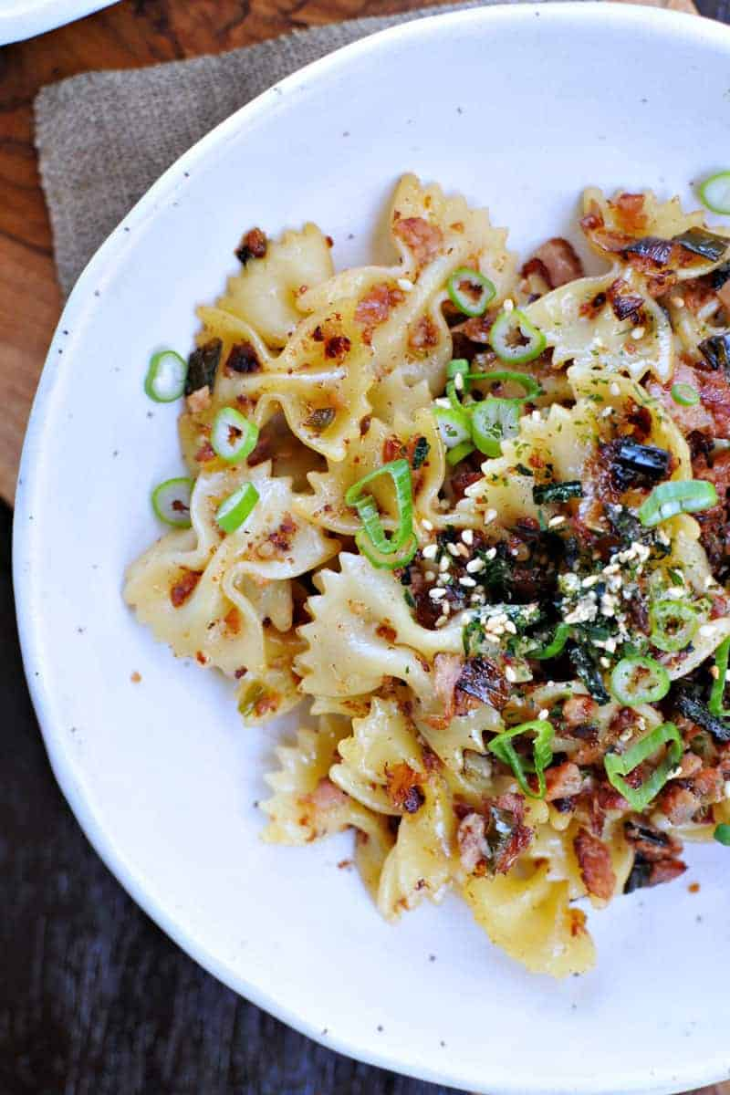
Instructions
- Cook pasta until al dente according to package instructions; drain and set aside, reserving ¼ cup cooking water.
- Heat butter in a medium saucepan or Dutch oven over med-high flame until just frothy. Add chopped green onions, season with salt and pepper, and sauté until bright green, 2-3 mins.
- Meanwhile mash spam with a potato masher until crumbly (about the texture of ground pork). Add spam, sugar, sesame oil and chile flakes to pan and cook until spam is browned and crisp in places and green onions are deeply golden and caramelized.
- Add pasta along with a splash of the reserved cooking water (start with a tablespoon or two -- we're just looking to help things cling together) and cook another minute to allow everything to meld and heat through.
- Serve pasta (either piping hot or at room temp) topped with more chopped scallions. Enjoy

